University of Nairobi

College of Biological and Physical Sciences

School of Computing and Informatics

Annual Report

2020

- Introduction
The School of Computing and Informatics (SCI) was formally established in 1977 as the Institute of Computer Science whose mandate included academic as well as university ICT services. In the year 2002, and in the interest of realizing more focused management and efficiency of the two functions, ICS was split into two units i.e. ICTC and SCI. The School takes its name from the core competencies that it seeks to nurture: Computing, to cover the theory and science of computation and Informatics to exemplify the practical outworking of this theory in technology and application. The School is a regional leader in research, research and development (R&D) and advanced education in computing. It was the first to offer Bachelors and Postgraduate degrees in Computer Science in the region.
The core mission areas are: Teaching and Learning, Research, Consultancy, Research and Development and Extension Services

Teaching and Learning
Our objective in teaching and learning is to produce high quality, well-rounded, sophisticated graduates who are productive, innovative, and capable of lifelong learning. Our courses are therefore developed and delivered to a high standard of educational and technological competence.

Research
We aim to institute a dynamic programme of aggressive research in our core areas of competence: information systems, distributed systems and artificial intelligence, in line with national and regional prioritises.
Consultancy
We seek to engage productively with the public and private sector to solve problems of national or organizational economic importance in order to foster progress in our environment. A number of our academic staff members are involved in consultancy work through UNES.
Research and Development and Extension Services
Based on sound research, relevant teaching, and problem-solving experience gained through consultancy opportunities, we develop training programmes, policies, methodologies and information technology software and hardware products for the local, regional and international market and increase awareness of the same in the community at large.
Thematic Areas
The research mandate of the School of Computing and Informatics is carried out under three research groups in the following thematic areas:
- ICT for development (ICT4D)
- Computational Intelligence
- Distributed Computing

- Programmes Offered
Programmes | Year Started | Summary
B.Sc. Computer Science, Diploma in Computer Science | 1993 | This is the School's flagship programme. Continues to attract high caliber students. We admit a second class at Kenya Science campus in addition to the class based in Chiromo campus. Curriculum has been reviewed 5 times. Most recent review in 2019 March.
M.Sc. Computational Intelligence | 2013 | This is an evening programme targeting applicants with first degree in Computer Science or related Engineering, Mathematics or Statistics discipline. Mode of study is coursework and project. Curriculum is currently under review
M.Sc. Distributed Computing Technology | 2013 | This is an evening programme targeting applicants with first degree in in Computer Science or a related discipline (e.g. Engineering, Mathematics and Physics). Mode of study is coursework and project. Curriculum is currently under review
`M.Sc. Information Technology Management | 2013 | This is an evening programme targeting applicants with first degree in Computer Science or Information Technology or a related discipline. Mode of study is coursework and project. Curriculum is currently under review
Ph.D. Information Systems, Ph. D. Computer Science | 2000 | These are Ph.D. purely by research. The program was reviewed in May 2019 and its course work and Research .The programmes have produced 24 graduates so far. Currently over 60 students are registered.

- Undergraduate Enrolment
Year of Study | Number of students
 | Government Sponsored |  |  |  | Privately Sponsored |  |  |  |  |  | Totals
 | Male | Female | Total |  | Male |  | Female |  | Total |  | Male |  | Female |  | Total
1 | 34 | 13 | 47 |  | 42 |  | 8 |  | 50 |  | 76 |  | 21 |  | 97
2 | 36 | 9 | 45 |  | 79 |  | 13 |  | 92 |  | 115 |  | 22 |  | 137
3 | 25 | 8 | 33 |  | 76 |  | 10 |  | 86 |  | 101 |  | 18 |  | 119
4 | 26 | 8 | 34 |  | 45 |  | 8 |  | 53 |  | 71 |  | 16 |  | 87
Total | 121 | 38 | 159 |  | 242 |  | 39 |  | 281 |  | 363 |  | 77 |  | 440

- Postgraduate Enrolment

Masters Programmes
Year of study |  |  |  | Number of students
 | M.Sc. IT Management |  |  | MSc Computational Intelligence |  |  | MSc Distributed Computing Technology |  |  | Grand Total
 | Male | Female | Total | Male | Female | Total | Male | Female | Total
1 | 20 | 4 | 24 | 27 | 6 | 33 | 12 | 3 | 15 | 72
2 | 36 | 14 | 50 | 22 | 7 | 29 | 19 | 4 | 23 | 102
Total | 56 | 18 | 74 | 49 | 13 | 62 | 31 | 7 | 38 | 174

PhD
Level | Male | Female | Total
1 | 16 | 5 | 21
2 | 17 | 6 | 22
3 | 22 | 7 | 29
Total | 55 | 18 | 72

- International Student Component
Reg. Number | Student Name | Gender | Country
P15/100014/2017 | Arow John Alier Majok | M | Australia
P15/101326/2017 | Orio Kenedy | M | Tanzania
P15/43771/2017 | Maiki Mambia Emanueli | M | Tanzania
P15/130671/2018 | Okech Allan Ongom | M | Uganda
P15/141008/2020 | Twaakyondo Ibrahim Salim | M | Tanzania
P15/138525/2019 | Ecil Paul Pennuel | M | Uganda
P15/132423/2018 | Mabor Michael Makuaac Maker | M | South Sudan
P15/44418/2017 | Haar Ajach Anuer | M | South Sudan
P15/138525/2019 | Ecil Paul Pennuel | M | Uganda
P15/138521/2019 | Mareech Makuach | M | South Sudan
P15/137741/2019 | Thon Peter Mawut | M | South Sudan
P54/34840/2019 | Anisa Ali Hassan | F | Somalia
P54/32411/2019 | Akol Akol Anei Arop | M | South Sudan
P54/12247/2018 | Hersi Mohamed Hassan | M | Somali
P53/72934/2014 | Bahati Protus Goodluck | M | Tanzania
P58/73247/2009 | Kapumba Michel Mwandu | M | D.R. Congo

- Number of Graduates
DEGREE PROGRAMMES | Male | Female | Total
Diploma in Computer Science | 27 | 9 | 36
BSc in Computer Science | 52 | 11 | 63
MSc in Information Systems | 1 | 0 | 1
MSc in Computer Science | 4 | 0 | 4
M.Sc. IT Management | 14 | 11 | 25
MSc Applied Computing | 3 | 1 | 4
MSc Computational Intelligence | 4 | 3 | 7
MSc Distributed Computing Technology | 15 | 1 | 16
Ph.D. Information Systems | 0 | 0 | 0
Ph. D. Computer Science | 2 | 0 | 2
Total | 122 | 36 | 158

- Research Projects
Title | Partners
Health IT Project | USAID
Digital Matatus | Costworld Foundation
HIV Capacity building (UNITID) | UNITID
Africa Climate Change Leadership Program (AFRICLP) | Institute of research Assessment(IRA,IDRC)
Quantifying the contribution of forage technology adoption and advise on policy targets under the Kenya Climate Smart Agriculture Strategy | KALRO
Data Center Management, Maintenance and Support Services | KeeRA

- Publications
S/No. | AUTHOR | TITLE | JOURNAL | MONTH & YEAR
 | Frankline Makokha, Christopher K. Chepken, and Elisha T. Opiyo | A Comparative Study of a Client Based Vendor Neutral Cloud QoS Monitoring Tool and Cloud Providers’ Platform Integrated QoS Monitoring Tools | EJECE, European Journal of Electrical Engineering and Computer Science | January 2020
 | Benard Mutisya Nzyoka Nzyoka, David Muchangi Mugo, Stephen Mburu Ng’ang’a | Medical Device Integration with Electronic Health Records: A Case Study of University of Nairobi Health Services, Kenya | International Journal Of Computers & Technology | January 2020
 | Grace Leah Akinyi and Robert Oboko | Proposed Self-Regulation Model for Collaborative E-Learning Systems in Kenyan Public Universities | American Journal of Engineering and Applied Sciences | January 2020
 | Eric Araka, Elizaphan Maina  , Rhoda Gitonga and Robert Oboko | Research trends in measurement and  intervention tools for self-regulated learning  for e-learning environments—systematic  review (2008–2018) | Research and Practice in Technology Enhanced Learning | 2020
 | Rachael Njeri Kibuku, Prof. Daniel Orwa Ochieng  and Prof. Agnes Nduku Wausi | e-Learning Challenges Faced by Universities in Kenya: A Literature  Review | The Electronic Journal of e-Learning | February 2020
 | David Gureya, João Neto, Reza Karimi, João Barreto, Pramod Bhatotia, Vivien Quema, Rodrigo Rodrigues, Paolo Romano, Vladimir Vlassov | Bandwidth-Aware Page Placement in NUMA Systems | 34th IEEE International Parallel & Distributed Processing Symposium (IPDPS) | March 2020
 | Kevin Obiero, Ted Lawrence, Jessic aIves, Stephanie Smith ,Friday Njaya, Robert Kayanda, Herwig Waidbacher,Dan Olago, Evans Miriti, R.E.Hecky | Advancing Africa’s Great Lakes research and academic potential: Answering the call for harmonized, long-term, collaborative networks and partnerships | Journal of Great Lakes Research | February 2020
 | Kwale F.M., Wagacha P.W. and Kahonge A. M. | A Clustering Accuracy Comparison Framework | African Journal of Education, Science and Technology | March 2020
 | Boniface Akuku, Timothy Mwololo Waemaand Robert Oboko | Institutionalization of knowledge management strategies in agricultural research organizations: a systematic literature review | Knowledge Management for Development Journal | March 2020
 | Walter Buyu,Elisha O.Abade | Forensic Analysis of Dropbox Data Remnants on windows 10 | International Journal of computer Application | July 2020
 | Michael M Kangethe,Elisha O,Abade | Dynamic Directional NxN Chart Based Text Based Substitution Cipher | Journal of Computer Science and Applications | September 2020
 | Michael M Kangethe,Robert Oboko | Association Rankings Model for Cellular Surveillance Analysis | Journal of Computer Science and Applications | July 2020
 | Simon kihiu,Elisha Abade | Comparative Analysis of Distinctive Features of the Ransomware tactics in Relation to other Malware | International Journal of Computer | July 2020
 | Justin M Njeru,Elisha O,Abade | A Survey on Big Data Analytics Architecture for Urban Transport System:A case for Nairobi Metropolitan | International Journal of computer Application | September 2020
 | John onyiego,Odira Elisha Abade | Supervisory Control and Data Acquisition(SCADA) System Forensics Based on the Modbus Protocol | International Journal of Computer | August 2020
 | Boniface Akuku, Timothy Mwololo Waema and Robert Oboko | Institutionalization of knowledge management strategies in agricultural research organizations: a systematic review of the international literature | Knowledge Management for Development Journal | September 2020.
 | Jecinta Muthoni Ndungu,Christopher A.Moturi | Determinants of Mobile Fintech Update in Kenyan Microfinance Sector | Current Journal of Applied Science and Technology | September 2020.
 | Wanjiku Nganga,Ikechukwu Achebe | Spoken word Corpus and dictionary definition for an African language | Journal data Mining and digital Humanities | August 2020
 | Dennis M.Muriuki,  Lawrence G.Muchemi | A Recommendation System for retail Banking products | African Jounal of Mathematics and Computer Science Research | September  2020
 | Veronicah Owino,Timothy Waema | Digital Transformation as A Source of Competitiveness among Small and Medium Enterprises in Nairobi City County,kenya | Journal of Business and management | August 2020
 | Erick O.Otieno,  Agnes N.Wausi  Andrew M.Kahonge | Exploring the Factors That Contribute Towards Information Security Policy Compliance Culture | Information and Knowledge Management | August 2020
19 | Edward Buhasho,Agnes Wausi,James Njihia | Business Intelligence Capability,Complementary Resources and Performance among Public Listed Firms in Kenya | Information and Knowledge Management | August 2020
20 | Noel K. Joseph, Peter M. Macharia, Paul O. Ouma, Jeremiah Mumo, Rose Jalang’o, Peter W. Wagacha, Victor O. Achieng, Eunice Ndung’u, Peter Okoth, Maria Muñiz, Yaniss Guigoz, Rocco Panciera, Nicolas Ray & Emelda A. Okiro | Spatial access inequities and childhood immunisation uptake in Kenya | BMC Public Health | September 2020
21 | Christopher Moturi; Geofrey Ogoti | Strengthening technology risk management in mobile money lending | International Journal of Financial Services Management | October 2020
22 | Charles Lwande, Robert Oboko & Lawrence Muchemi | Learner behavior prediction in a learning management system | Educ Inf Technol | November 2020
23 | Edwin O. Ngwawe,  Elisha O. Abade, Stephen N. Mburu | Context-Aware Computational Trust Model for Recommender Systems | EJECE, European Journal ofElectrical Engineering and ComputerScience | November 2020
24 | Erick. O. Otieno,  Agnes N. Wausi,  Andrew M. Kahonge | A Theoretical Model for Information Security Policy Compliance Culture | International Journal of Applied Information Systems | September 2020

- Links/Collaborations/Partnerships

S/No | Partners | DETAILS** | DURATION
1 | KALRO | - Quantifying the contribution of forage technology adoption and advise on policy targets under the Kenya Climate Smart Agriculture Strategy; | 2020 - 2021
2 | USAID | - Providing support to the sustaining use of District Health Information System II in Kenya Program | September 2020-September 2021
3 | Costworld | - Supporting Digital Matatu Project | September 2020-September 2021
4 | Pompeu Fabra University Spain | - Mobility for learners and staff | 2020-2021
5 | KeRRA | - Data Center Management, Maintenance and Support Services | 2020-2021

- Human Resource

Designation/Grade | No of Staff
Professor | 3
Associate Professor | 4
Senior Lecturer | 8
Lecturer | 4
Tutorial Fellow | 4
Graduate Assistants | 0
Assistant Registrar | 0
Senior Administrative Assistant | 1
Admin Assistant | 0
Senior Secretary | 1
Secretary | 0
Network Engineer | 1
Senior Technologist | 2
Technologists | 2
Library Assistant | 1
Office Assistant | 0
Record Clerk | 1
Messenger | 0
Receptionist/Telephone Operator | 0
Cleaners | 1
Driver | 1
Total | 35

Staff Portfolio

Director:
Oboko, R.O., Bed (KU), PGDip C.S. (Nairobi), MSc (Brussels), PhD, (Nairobi)

Professor:
Waema, T.M., B.Sc. (Bath), PhD (Cambridge)
Omwenga, E.I., B.Ed (KU), PGDip.C.S (Nairobi), MSc (NUST), PhD (Nairobi)
Wagacha, P.W., BSc. (Nairobi), MSc (Shanghai), PhD (Nairobi)

Associate Professor:
Wausi, A.N., BSc (KU), PGDip C.S. (Nairobi), MSc (Brussels), PhD (Nairobi)
Opiyo, E.T.O., B.Ed (Nairobi), PGDip C.S (Nairobi), MSc (Brussels), PhD. (Nairobi)
Ochieng, D.O., BSc (Nairobi), MSc (Shanghai), PhD (Nairobi)

Senior Lecturer:
Moturi, C.A., BSc, PGDip C.S., (Nairobi), MSc. (Aston)
Ng’ang’a, J.W., BSc (Nairobi), MPhil (Cambridge), PhD (Helsinki)
Omwansa, T.K., BSc (Nairobi), MSc (Wichita StateUniversity), PhD (Nairobi)
Kahonge, A.M., BSc (Nairobi), MSc (Birmingham, UK)
Githiari, L.M., B.Tech.Prod. Eng. (Moi), MPhil.Prod.Eng. (Moi)
Chepken, C.K., BSc (Nairobi), MSc (Nairobi), PhD (Cape Town)
Abade, E.O., B.Sc (Nairobi), MSc. (Nagoya University, Japan), Ph.D.(Nagoya)
Miriti E.K., BSc (Nairobi), MSc (Nairobi), PhD (Nairobi)

Lecturer:

Ayienga, E.M., B.Ed (Kenyatta University), MSc (Sheffield)
Ronge, C.A., BSc (Nairobi), PGDip C.S (Nairobi), MSc (Newcastle)
Ruhiu, S.N., BSc (Nairobi), MSc (Manchester)
Mburu, S.N., BEd. Maths & Comp. Science (Kenyatta University), MSc (Nairobi)

Tutorial Fellow:
Ogutu, J.O., BSc. Maths & Comp. Science (JKUAT), Dip.Ed.Science (KSTC),
MSc (Nairobi)
Wangunyu, P.W., BSc (Nairobi), MSc (Nairobi)
Gureya, D.D., BSc (Nairobi) MSc (KTH Royal Institute)
Ochukut, S.A., B.Sc. (Masinde Muliro University), MSc (Nairobi)

Network Engineer
Rabala, P.O.H. Higher Nat. Dip in Electronics (Kenya Poly), BSc. (Tech. in Elect Com. Eng. (Moi University), MSc (Nairobi)

- Promotions & Appointments
The School did have promotions

- Other Events (Please see attached photographs)

HUAWEI AWARDS
0
Huawei Awards
A third year student at the School of Computing and Information, Maluki Muthusi, was awarded the first prize for winning in the global Huawei ICT Competition in the
network track. This is a skill-based competition involving hands-on experience in computer
networks and network security. Over 109 teams from Asia, Europe, Southern, and Eastern Africa participated in the global finals. A total of 327 students managed to get to the global finals out of the 150,000 who had registered for the competition. The award ceremony that took place on January 18, 2020, at Serena Hotel, Nairobi and was presided by the PS for Education, Amb. Simon Nabukwesi, who reiterated the government's commitment to nurture ICT skills among the youths. The student later presented the prize to the Vice-Chancellor Prof Stephen Kiama.

machine learning with azure event on 19thFEBRUARY 2020.

AZURE IS MICROSOFT’S CLOUD COMPUTING PLATFORM
0
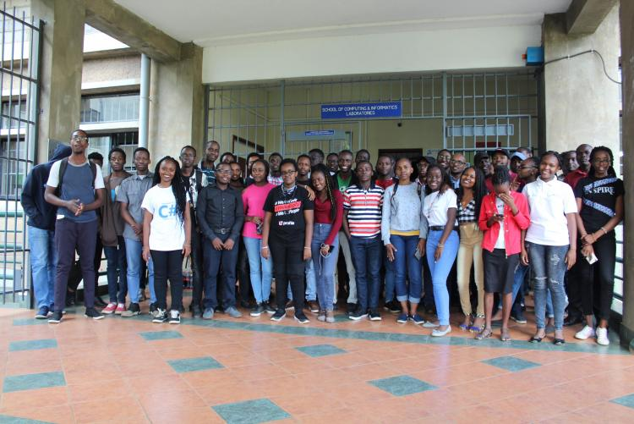

Microsoft student partner clubs are on-campus clubs around the world that seek to empower and help grow the local community through technology. On the afternoon of Wednesday February 19, 2020 from 2pm to 4 pm, the Microsoft student partners club at the University of Nairobi held an Azure fundamentals workshop.
Azure is Microsoft’s cloud computing platform where one is able to deploy and build their applications. An introduction to azure and hosting of an application using azure app service was done during the workshop.
Students with their student emails were able to access the student azure student’s account. An Azure for Students subscription includes $100 in Azure credits to be used within the first 12 months plus select free services without requiring a credit card at sign-up

MACHINE LEARNING WITH AZURE 19th FEBRUARY 2020.
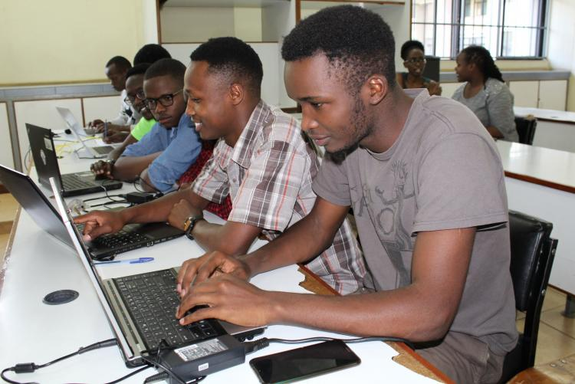
Machine learning

SCI STUDENT SELECTED AS THE UNIVERSITY DEVELOPER STUDENTS CLUB LEAD
Thabitha Kavyu, a third year student at the School of Computing and Informatics, was selected to be the Google Developer Students Club Lead of the University of Nairobi for the 2019 - 20 year. She is part of an amazing community of student leads who will be representing hundreds of colleges and universities across the globe. Her role is to help fellow students become competent software developers. She also trains them on the basics of coding by organizing events where students get to learn about emerging technologies such as Web, Android, Cloud and Artificial Intelligence. The position also entails bringing together women who are passionate about technology, and give them a platform to interact and learn from other successful women.

